# Overall Description

Shape

## **Product Perspective**

The system includes the user subsystem as well the seller subsystem. The online shopping system provides an outstanding way of bringing sellers and customers on an online platform to sell and make purchases in an efficient and secure manner irrespective of the distance between the two. It is a platform for customers to shop items online without having to visit a store or meet a seller physically, and a platform for vendors to sell their items online without having to meet the customers physically or have a physical store set up for his products. This system is a one stop for customers to shop from millions of products online. The seller uploads his listing to the system and the customers browse from these items and purchase them.

* 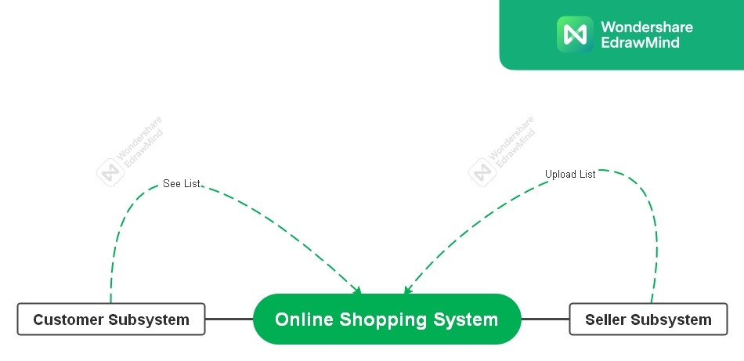  
  Register: for customers and sellers
* Login: for customers and sellers
* Logout: for customers and sellers
* View Account Details: for customers and sellers
* Edit Account Details: for customers and sellers
* Search item: for customers
* View item: for customers
* Add item to cart: for customers
* View shopping cart: for customers
* Change items in cart: for customers
* Proceed to buy: for customers
* Delivery & payment: for customers
* Place order: for customers
* Track order: for customers
* Cancel order: for customers
* Return item: for customers
* View orders and returns: for customers
* Rate item: for customers
* Review item: for customers
* Recommendations: for customers
* View sales: for sellers
* Get items: from sellers
* Upload listings: for sellers

## **User Classes and Characteristics**

Customer - He/she is a verified user of the system who is intended to buy a product sold by a seller using the platform. The functions used by customer are register, view account, login, browse item, view item, buy item now, add to cart, view cart, proceed to buy, enter delivery address, enter mode of payment, make payment, place order, view orders, track package, write review, cancel order, return item, logout. Seller - He/she is a verified user of the product who is intended to sell items over the platform. The product functions used by sellers are register, view account, login, upload listing, your sales, deliver the items to Deliver Company.

## **Operating Environment**

Operating Environment Web Application and mobile application running on the browser with a responsive design suitable for desktop view and mobile view.

## **Design and Implementation Constraints**

* For ease of maintenance, the customer will only be able to make payments once items have been added to cart.
* The wish list option has been merged with the cart as it serves very identical purposes.
* Due to interfaces with payment methods like google pay or PayPal, the risk for middle attacks is often higher and may require additional safety at payment gateways.
* As these systems lean heavily on the ability to make real -time updates, the servers must be capable of handling sufficiently high traffic bursts, which may not always be the case. Logistically, most companies outsource their tasks to a third party organization which costs them more control over their implementation.
* Compatibility with existing logistics APIs for delivery company operations.
* Restrict certain products or services to specific regions based on seller or delivery coverage.